HR Employee Survey Response

The Datset, “HR Employee Survey Response” I have taken from Kaggle.Dataset.com (Date Created: 31/01/2026)
About:
The Dataset contains the response that have been recorded by HR Department from the employees of four positions(Manager, Staff, Supervisor, Director).
In SQL, I have identified the count of response got from the Employees on each role and also I have able to find around 163 Persons where didn’t completed their response.
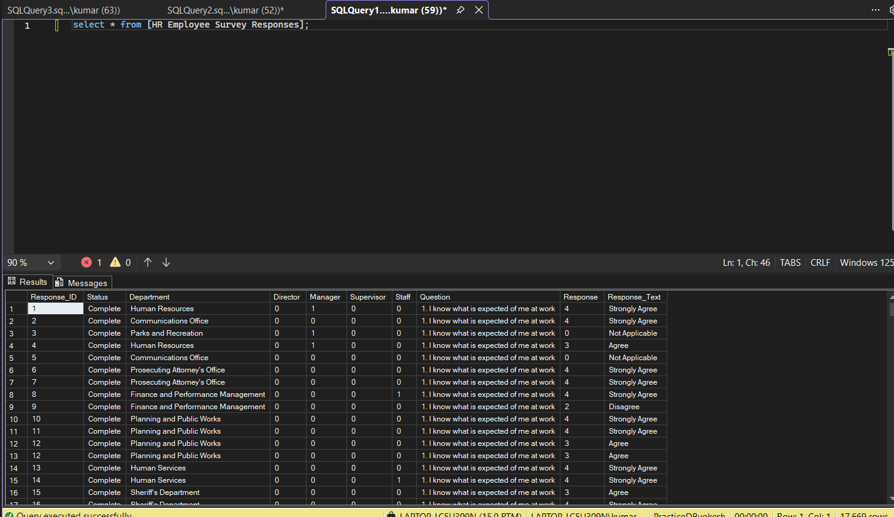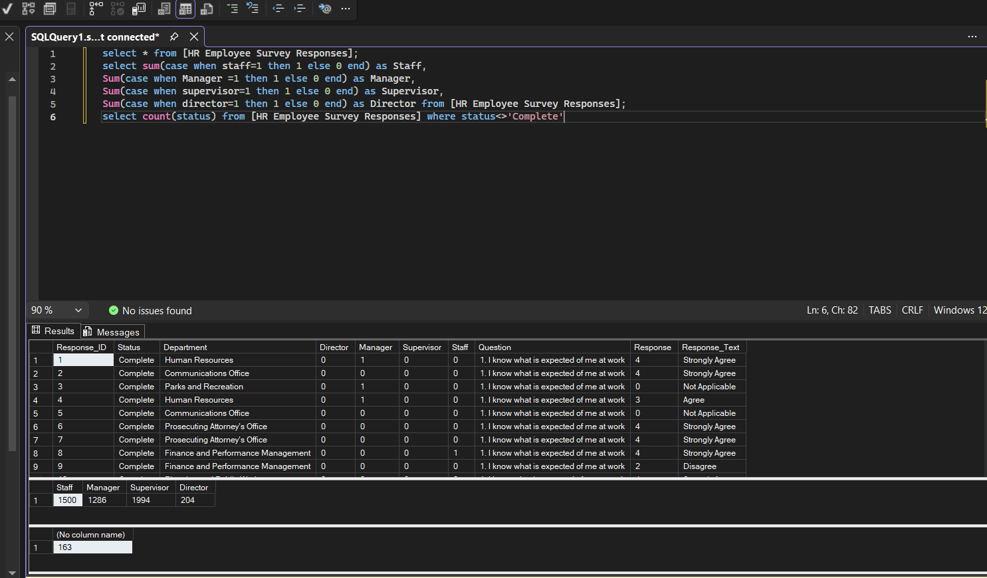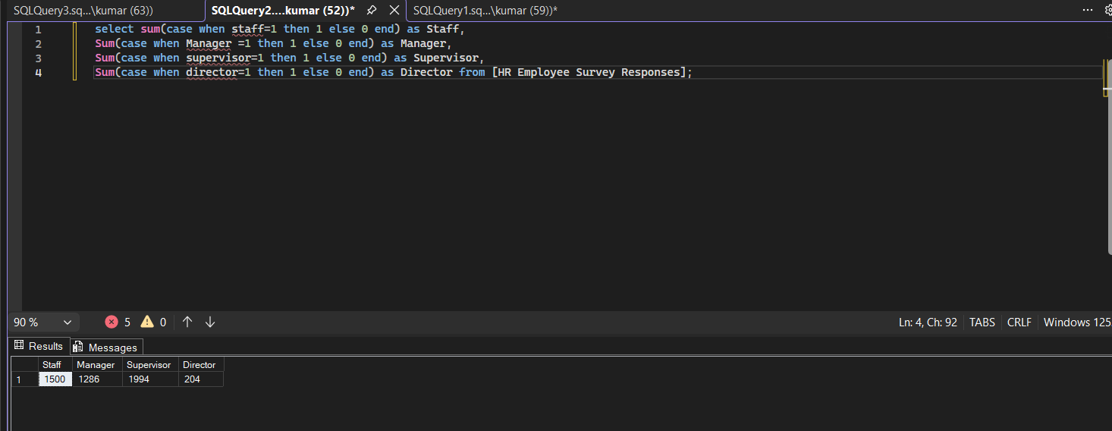
Similarly in Python, (Google Collab), I have did the same as I need to know the basic concepts here(in python) as well to perform the Machine Learning Operation in Upcoming Days.
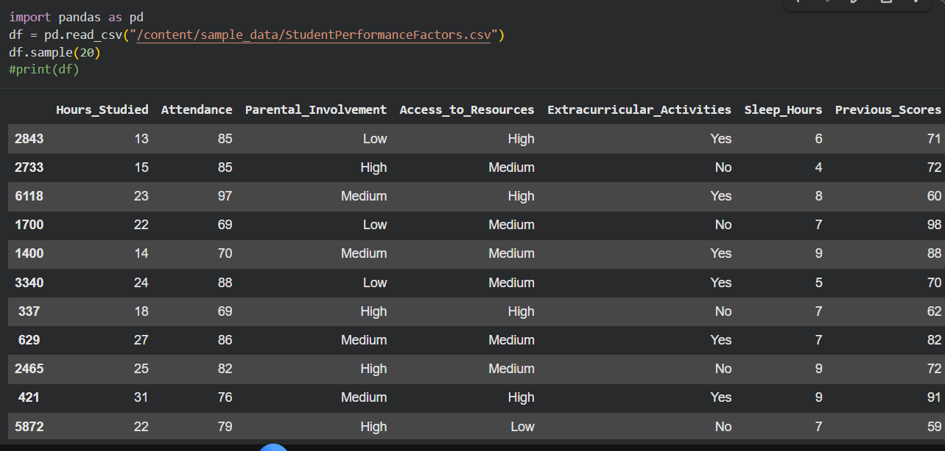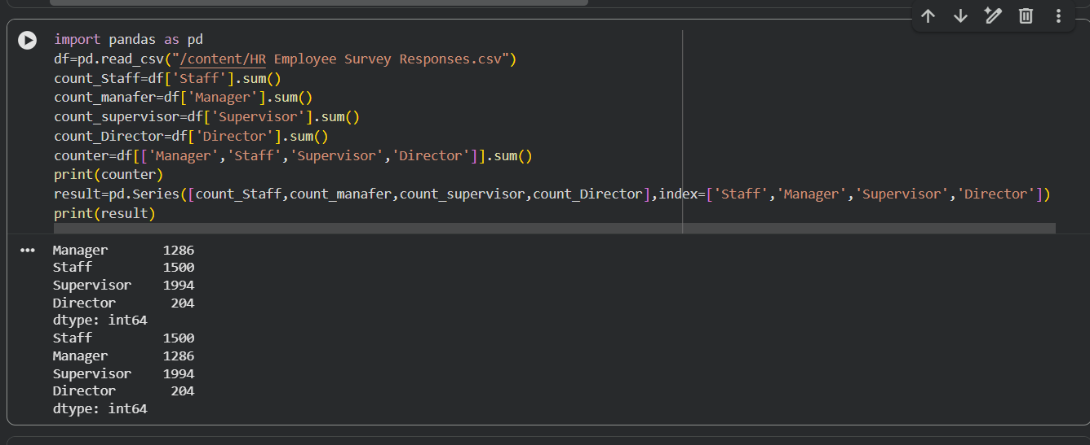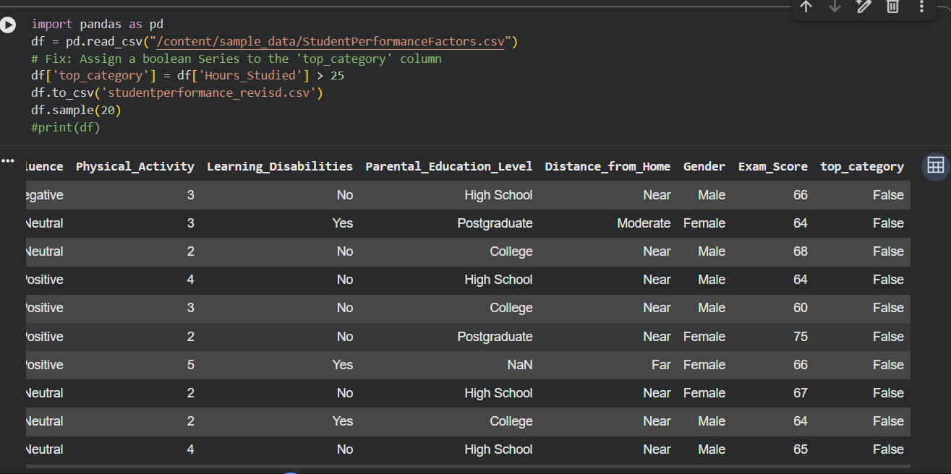

After this to get more insights, I have planned at which department the director is present, so i compiled this code and came to know that Director is present in “Exec Office & Directors” Department.

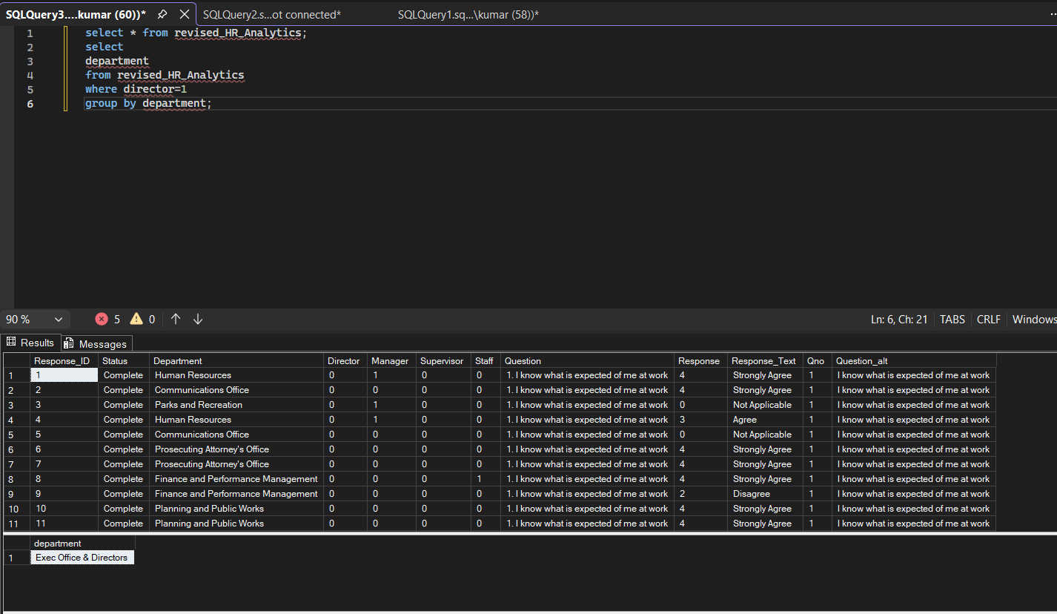
And in Finance and Performance Management we have a average of 13 response given by manager as for the each question the response . So, to make everyone aware I used windows function there(just for fun, I used there to brush up my concept). The purpose to do this is client(my mind) requested me to want the information particularly from Finance and Performance Management, to know there mindsets.
So, we go with managers, first here we take count as 13 managers in department(calculated based on average of response) and we have noted the average of marks for each question and average of total(in department).
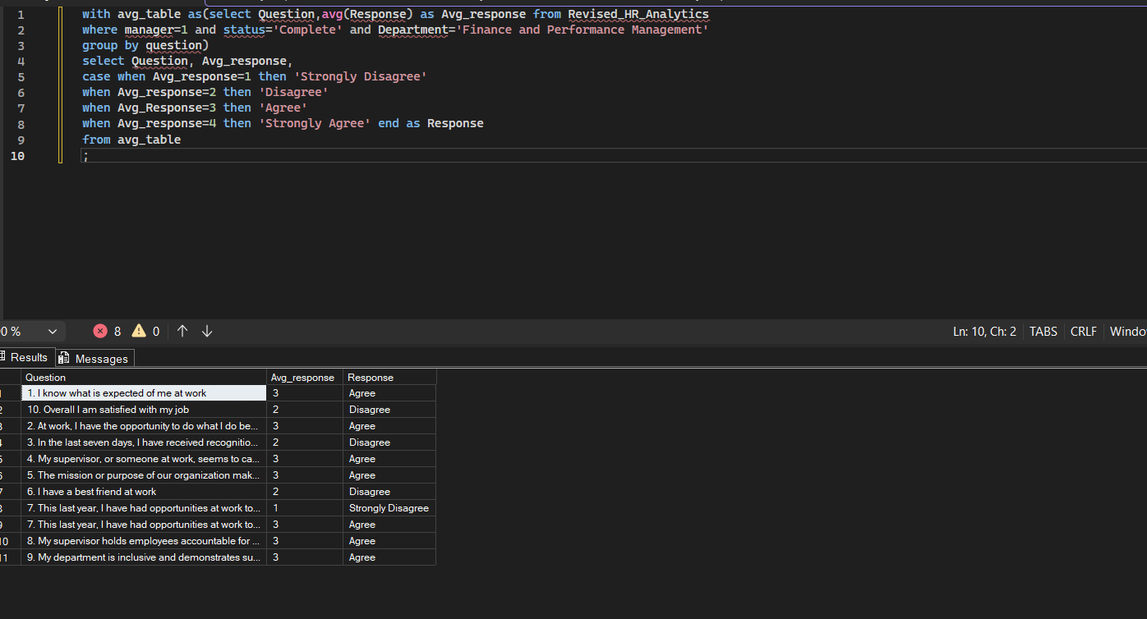
And also to know the staff’s mindset in workplace, as it helps organisation to plan their approach here is the data we got:
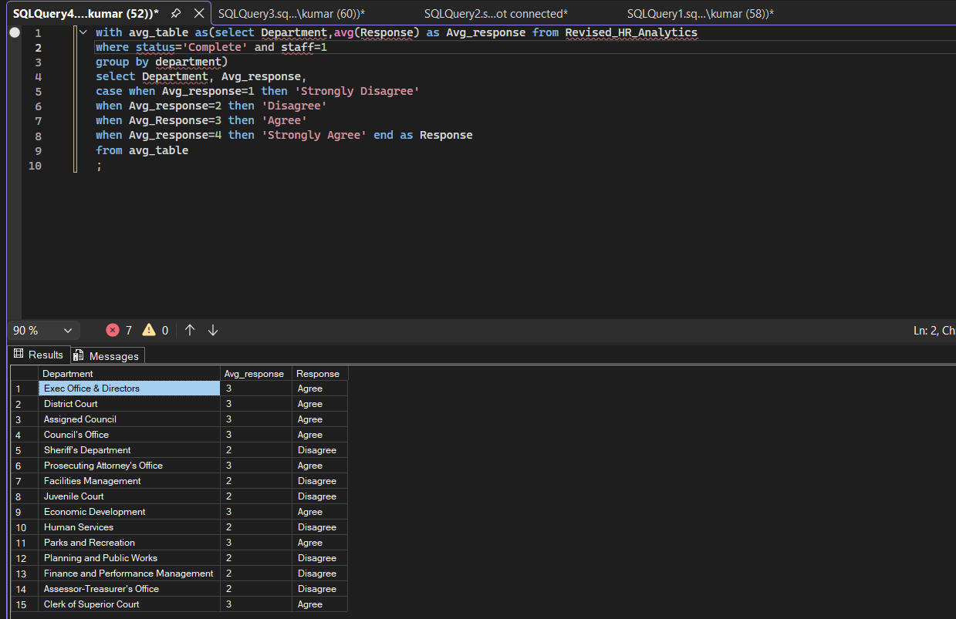
For now, we close this dataset, so if any data required in future we may enter the details here and make it as a tracker(Date of modified). We will do the same in python(to brush up our pandas and numpy concepts) later.

